- Write the program to find the family relation and sum of two numbers.
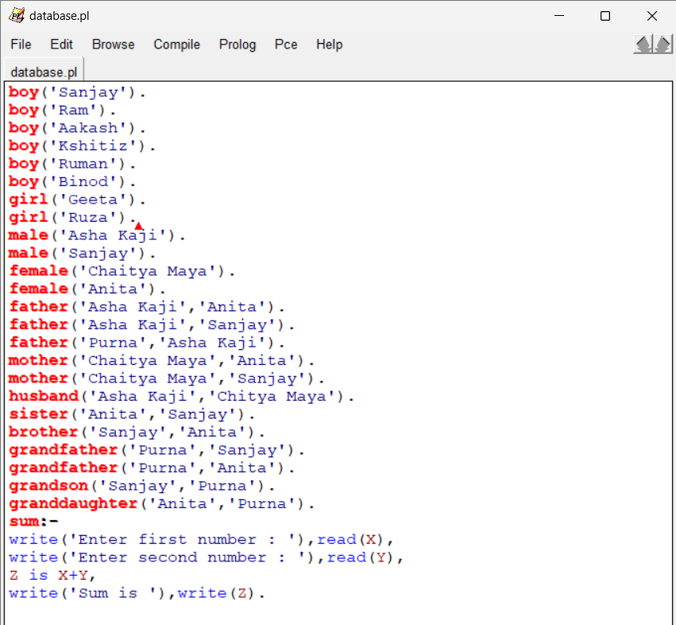

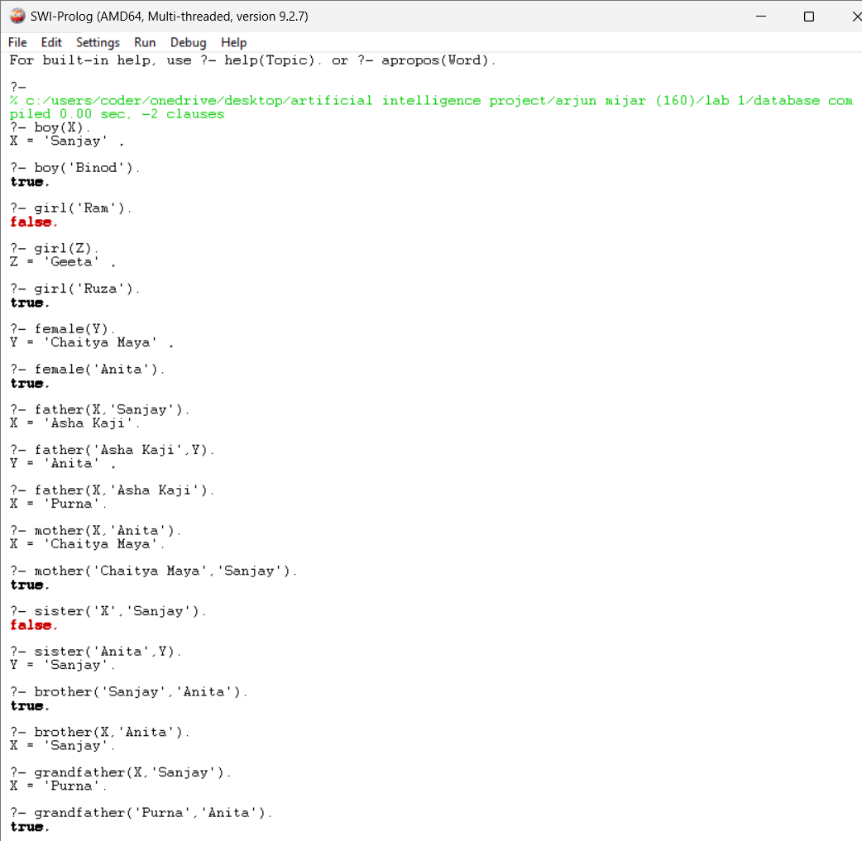

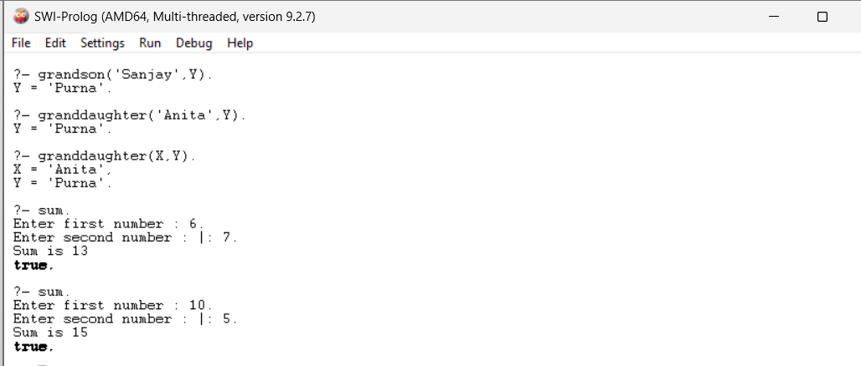
2a. Write a program to find the area and perimeter of a rectangle.
Write a program to find the area and circumference of a circle.
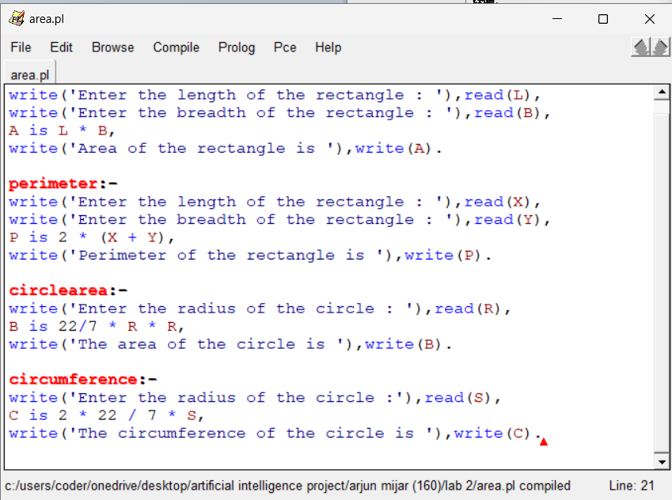

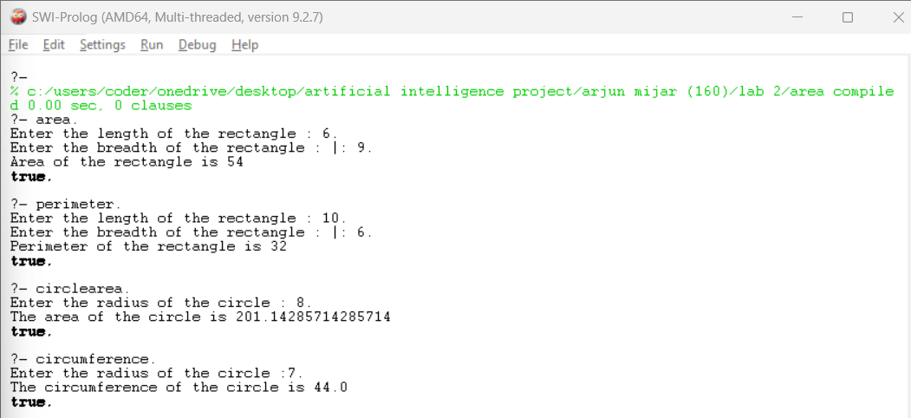

2b. Write a program to find the sum, difference, multiplication, division, and integer division.
Write a program to find the square, cube, and modulus.
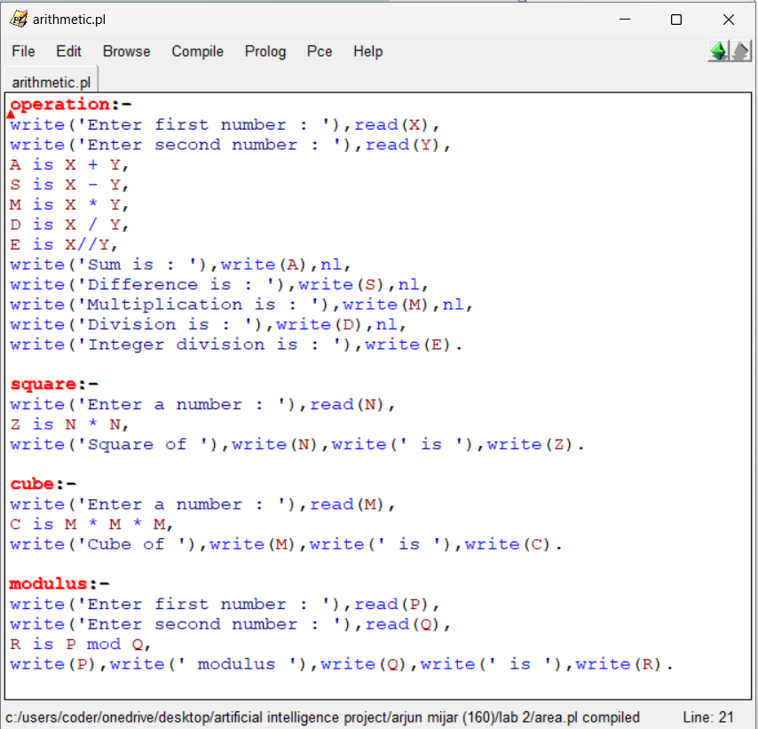
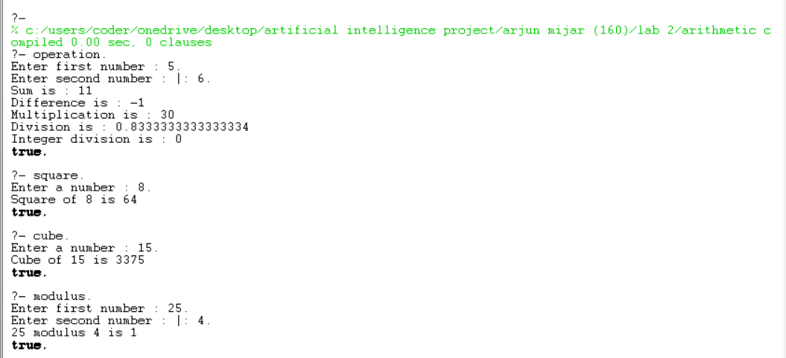

3a. Write a program to find factorial.
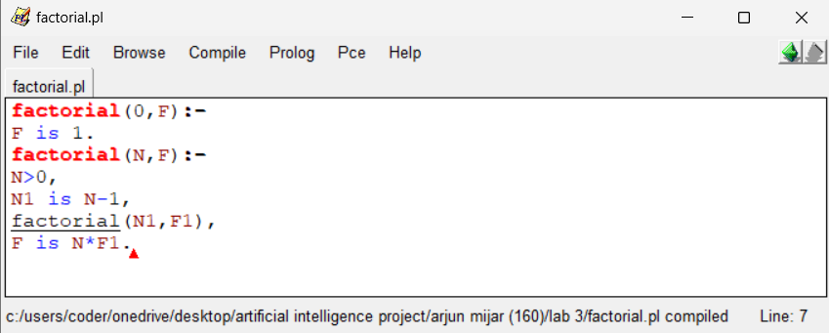
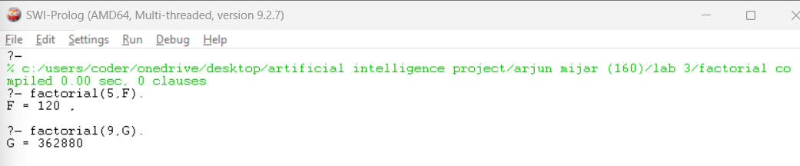

3b. Write a program to find fibonacci.
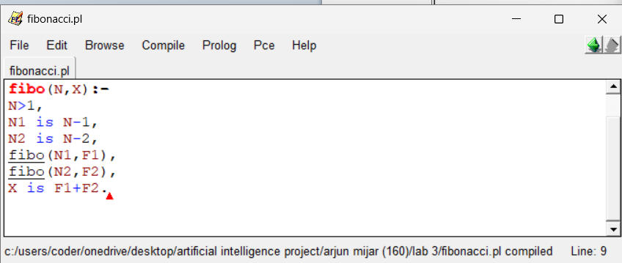
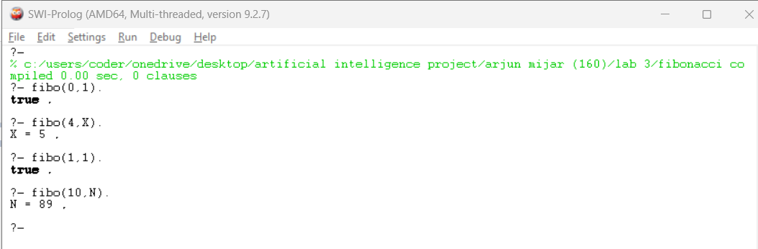

4a. Write a program to find the GCD and LCM of a given number.
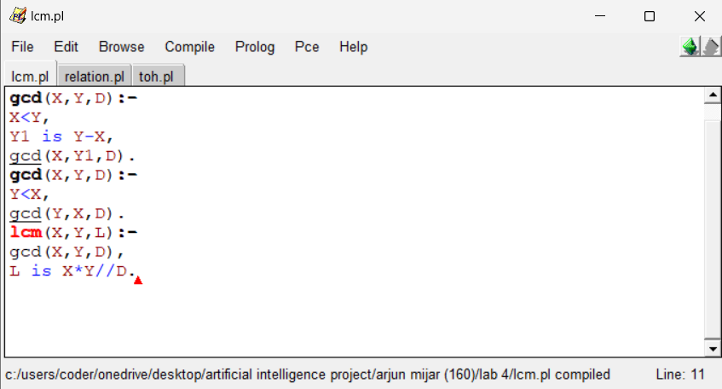
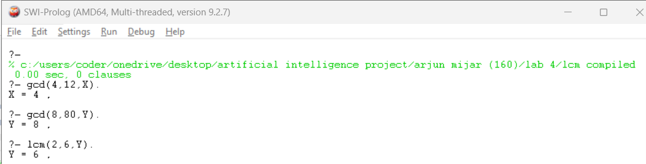

4b. Write a program to find the relation.
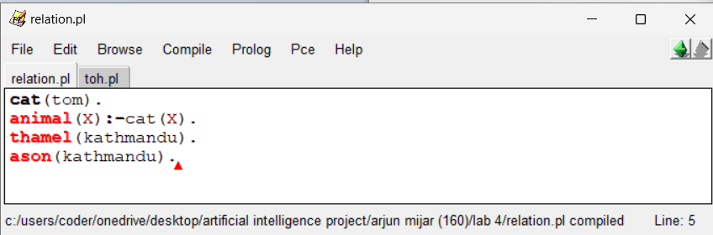
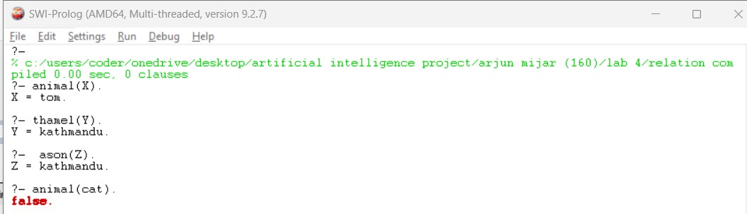

4c. Write a program to find the solution to a tower of Hanoi problem.
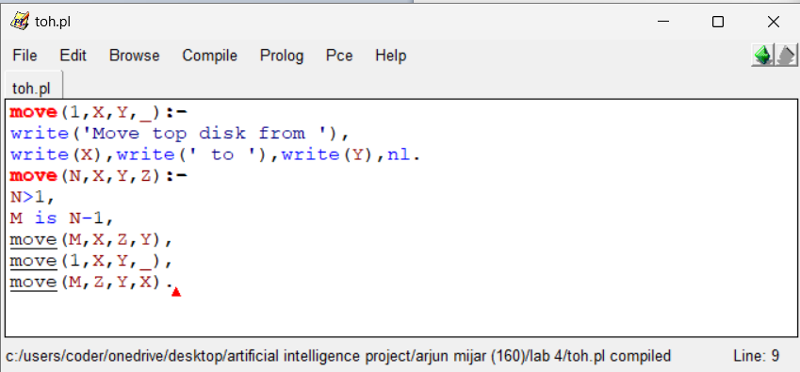
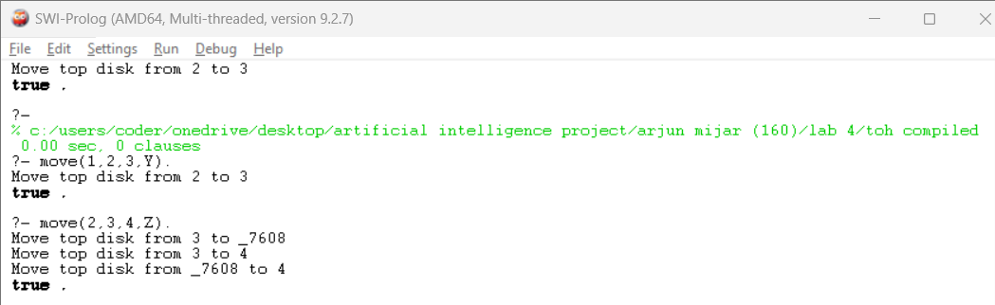

5. Write a program to find an area of a triangle.
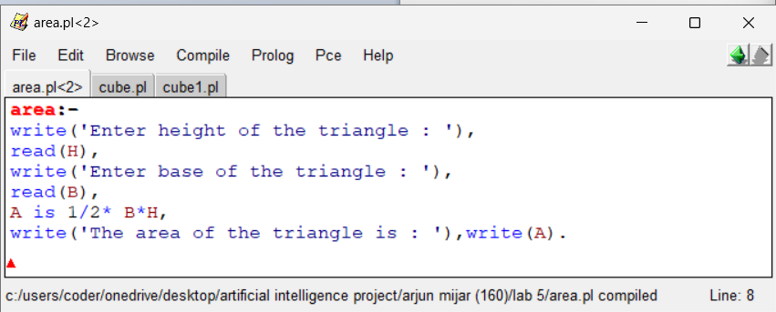
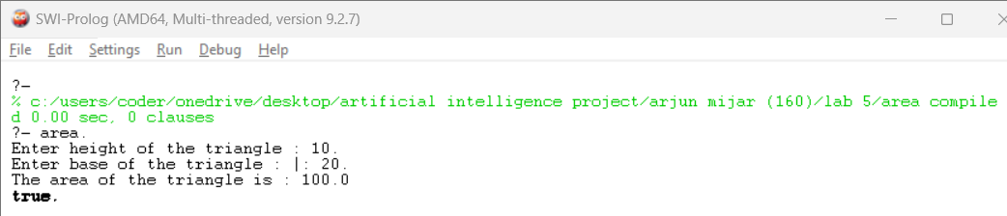

5b. Write a program to find the cube of a given number.
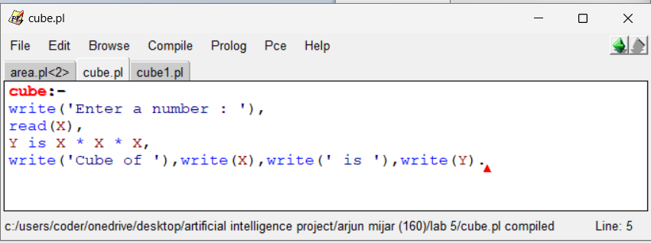
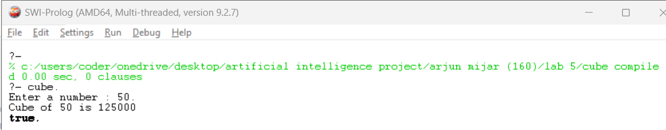

5c. Write a program to find the cube.
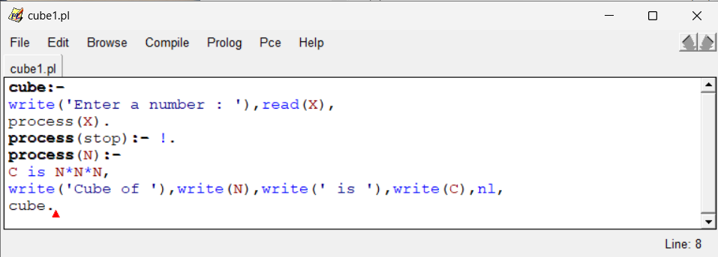
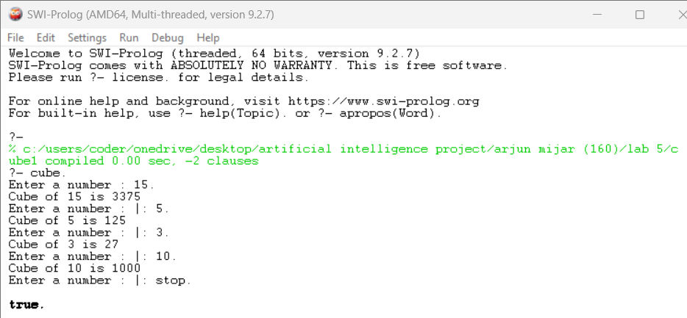

6a. Write a program to concatenation.
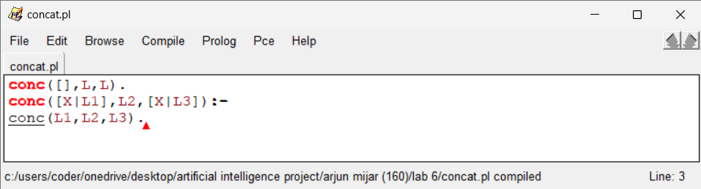
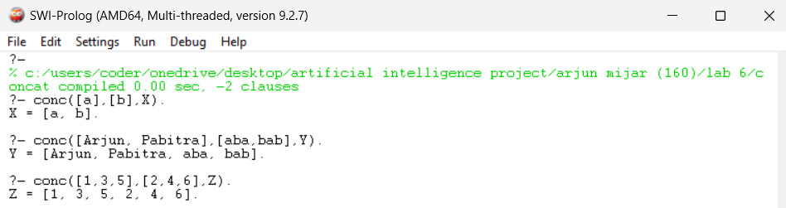

6.b Write a program to delete.
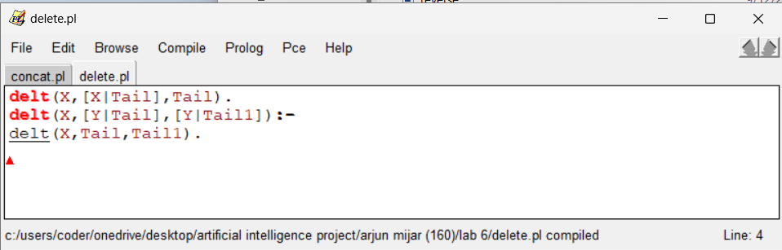
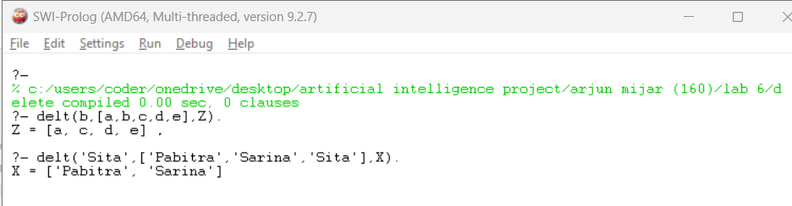
6c. Write a program to count the length of list.
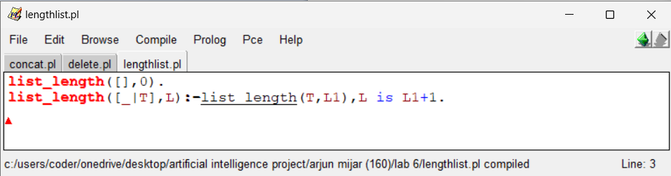
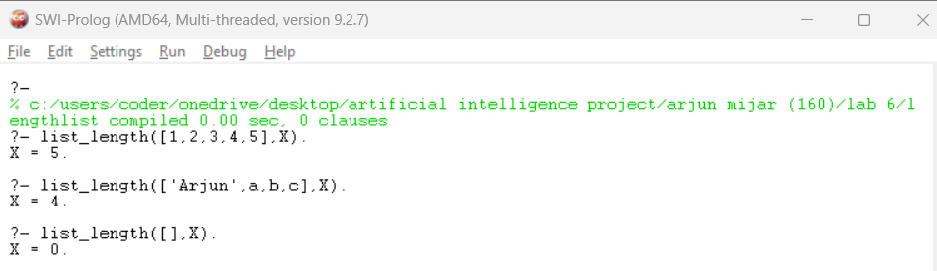

6c. Write a program to check whether the given member is list or not.
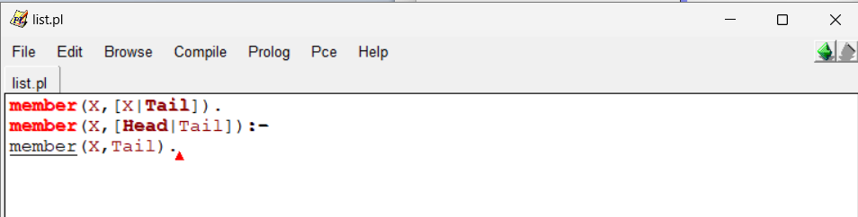

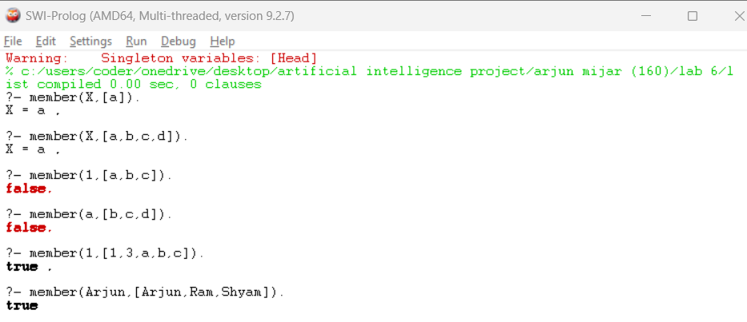

6d. Write a program to reverse a list.
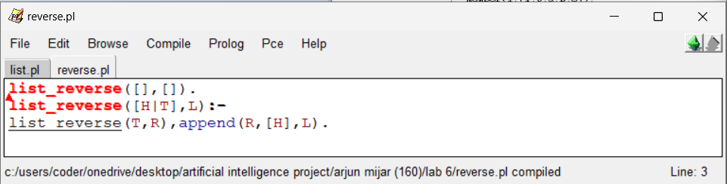
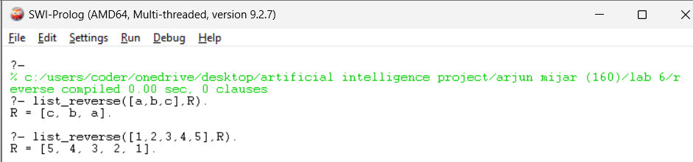
7a. Write a program to find the greatest number among given number.
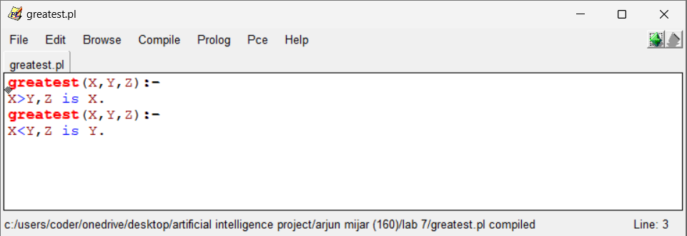
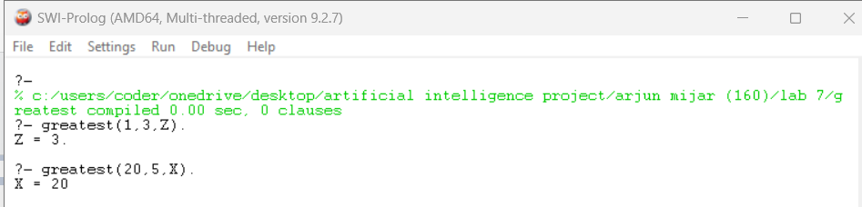

7b. Write a program to check the palindrome.
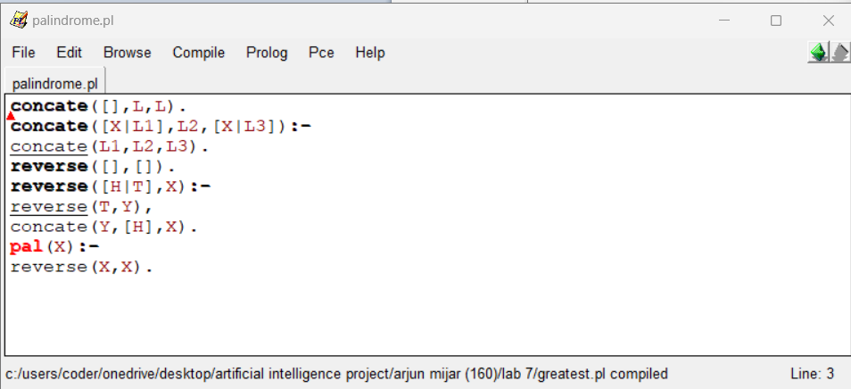
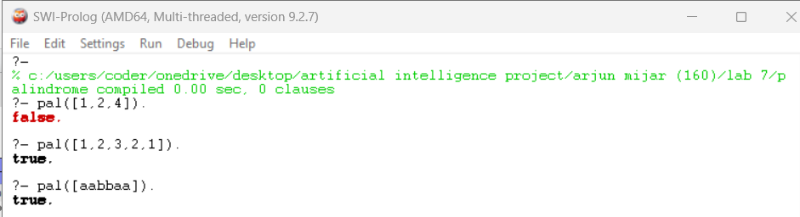

7c. Write a program to find the permutation.
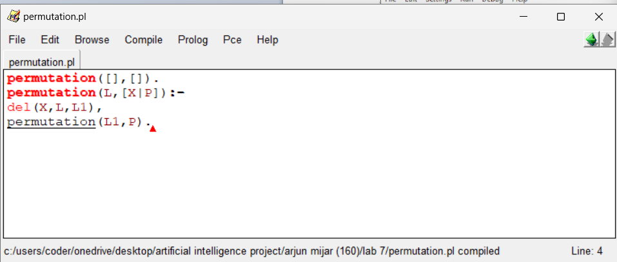
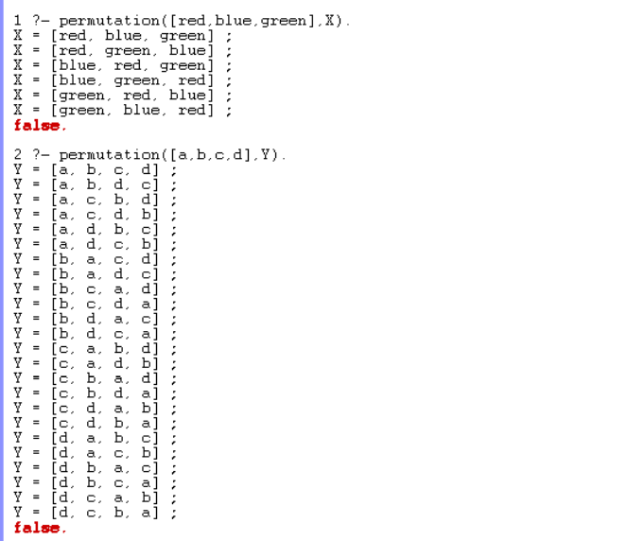
8a. Write a program to find the average of a given number.
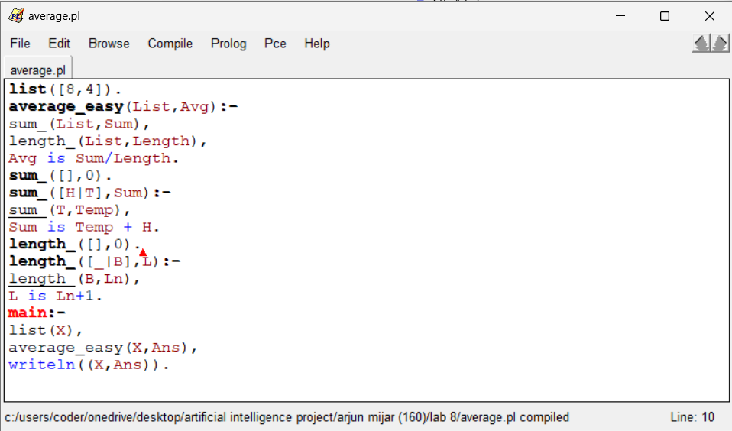
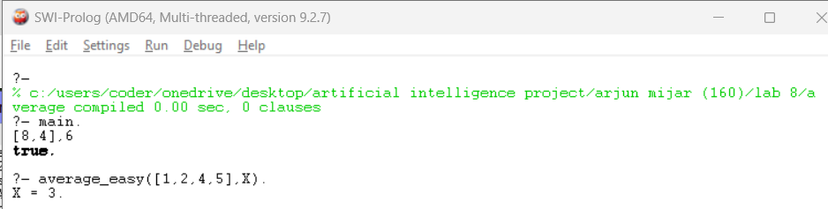

8b. Write a program to find the factor of given number.
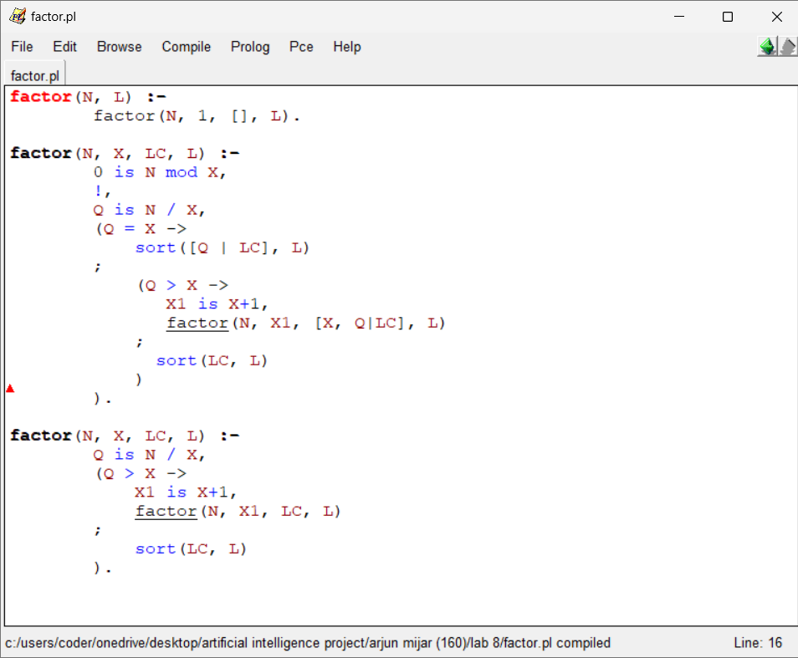
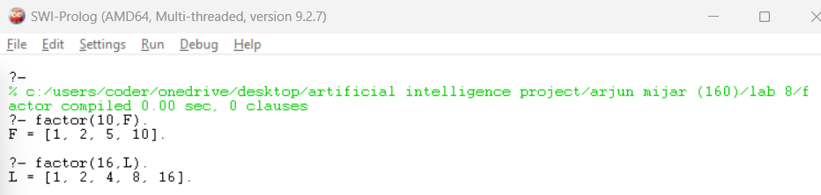

9a. Write a program to find the relation. (Who is mortal ?)
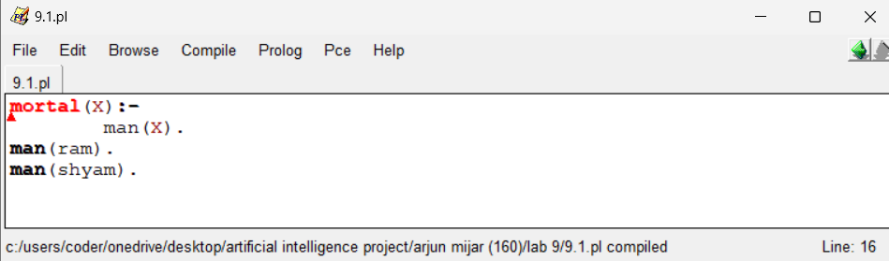
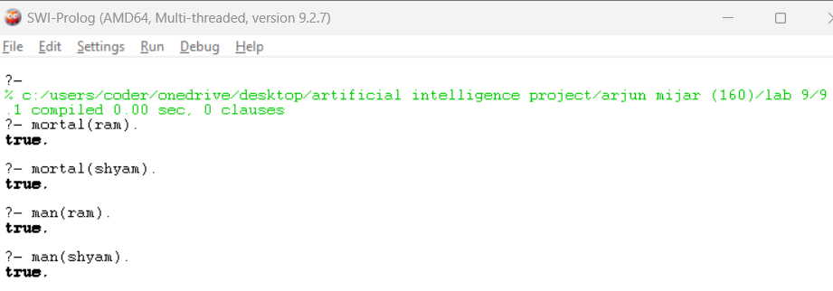

9b. Write a program to find the relation. (Which locations are in Asia ?)
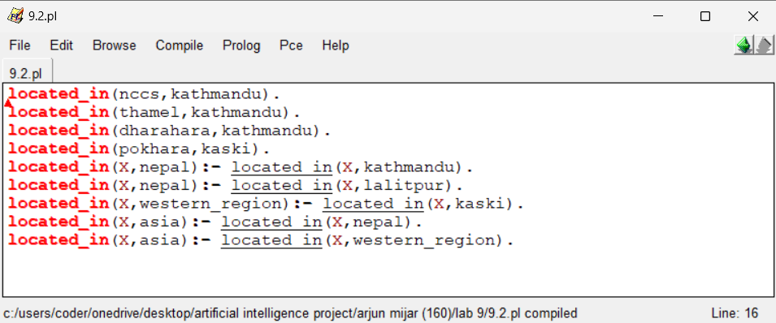
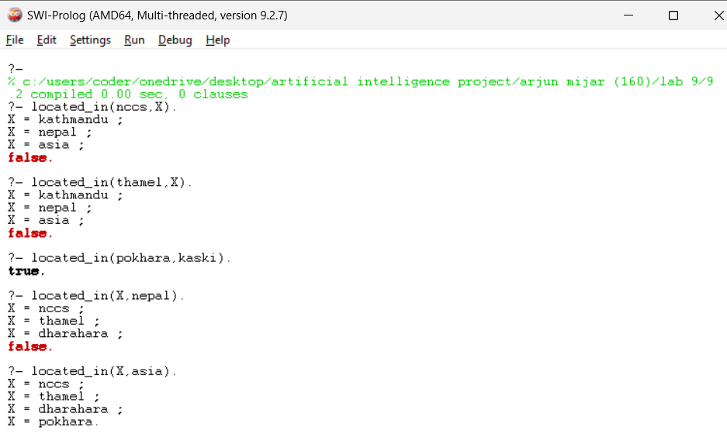

10a. Write a program to find the maximum number of given number.
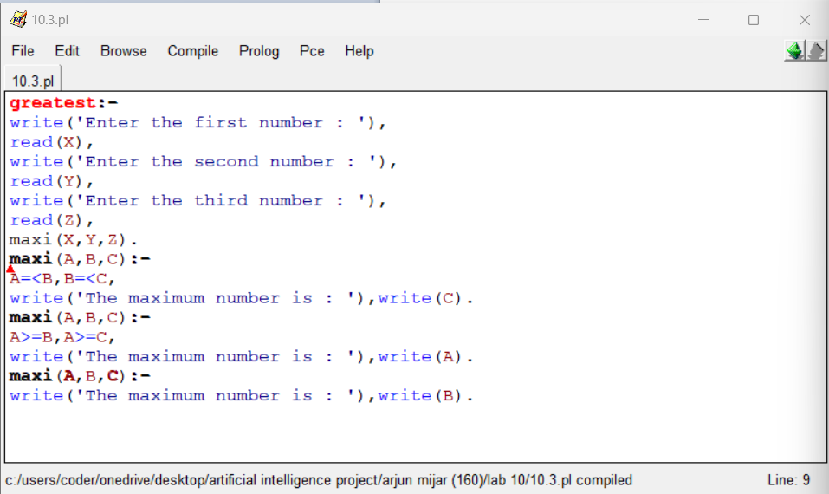
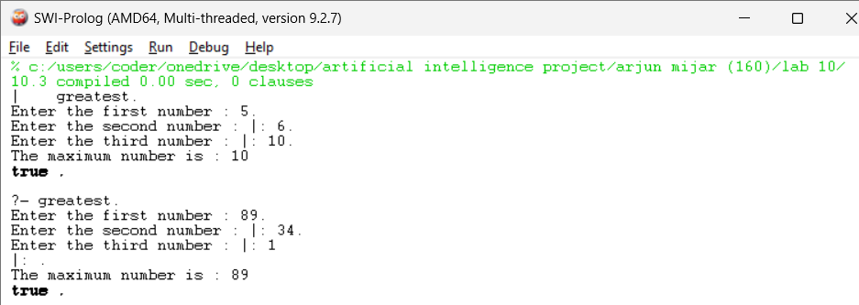

10b. Write a program to find the greatest number among given number.
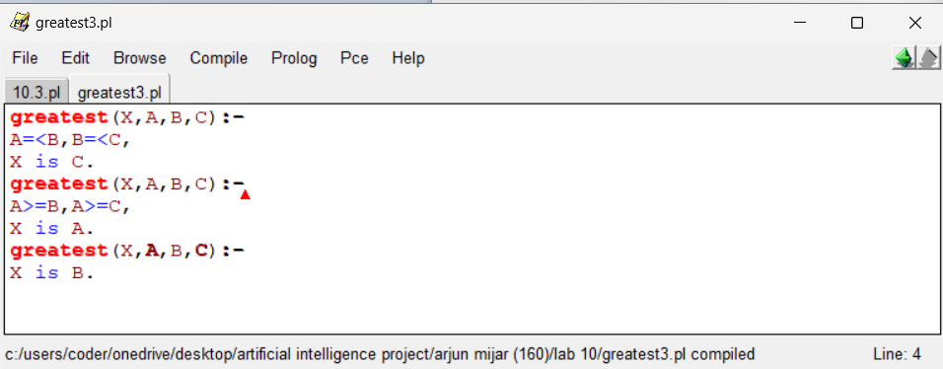
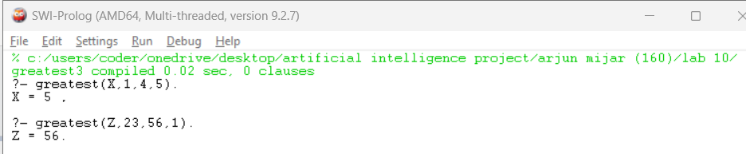

11a. What are the values of S, M, E, N, D, O, R, and Y that satisfy the equation SEND + MORE = MONEY?
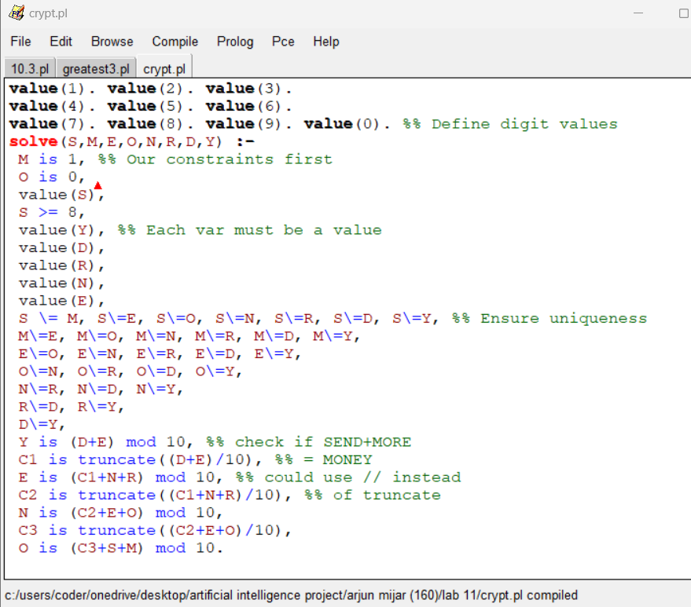
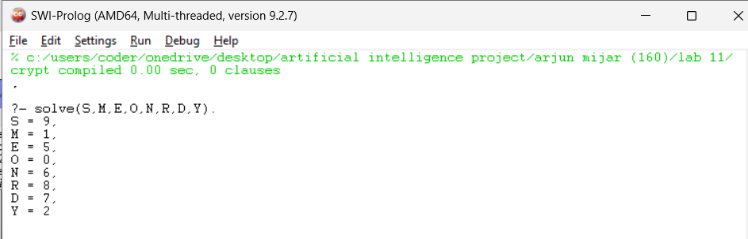

11b. Write a program to print a square of stars with a side length X.
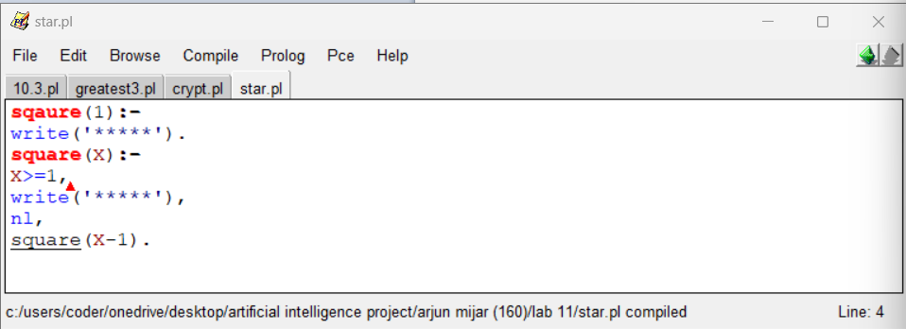
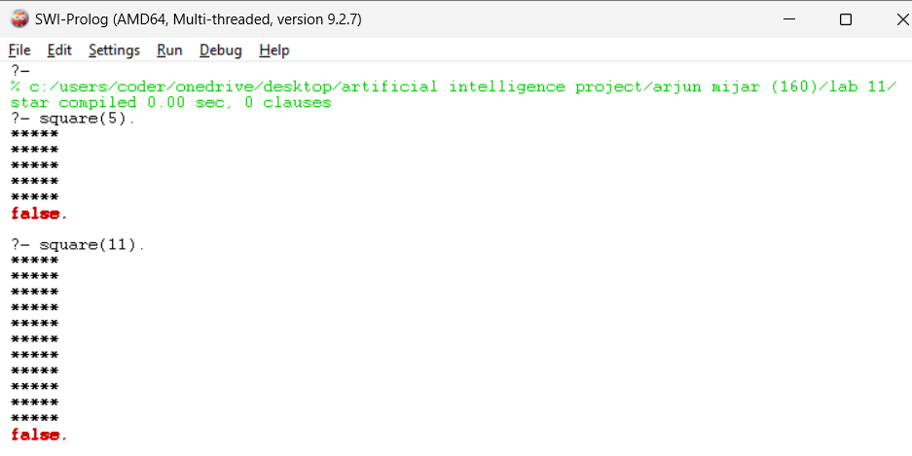

12a. Write a program to find the path from the start node to the goal node using breadth-first search.
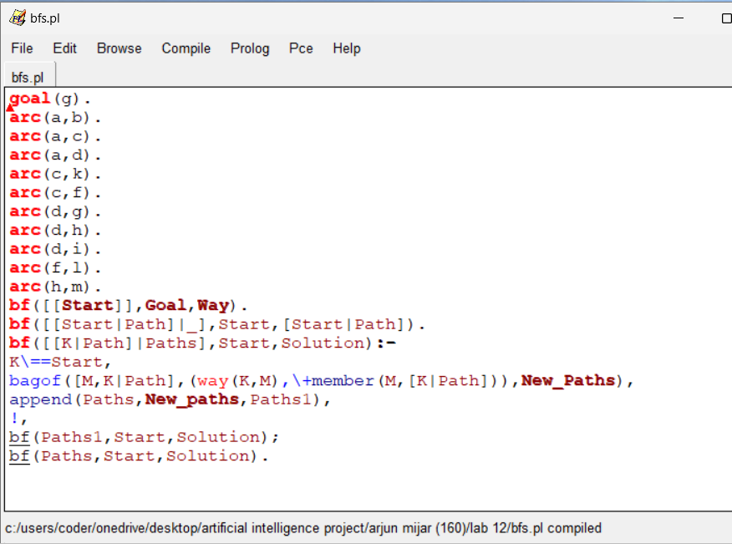
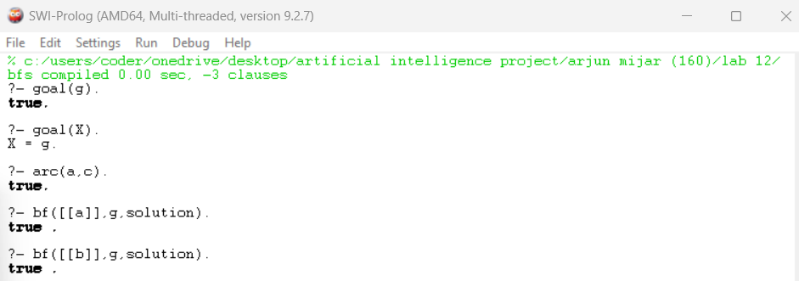

12b. Write a program to find the path from the start node to the goal node using depth-first search.
